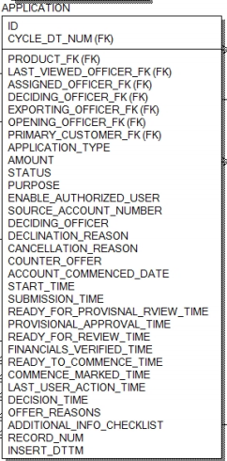**SQL Exercise:**

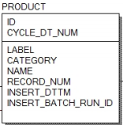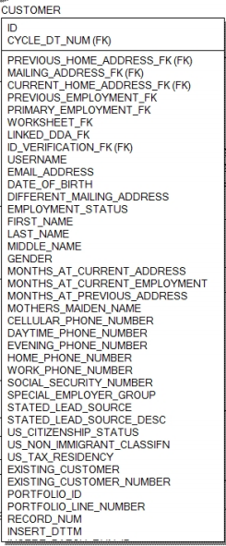

**Key:**

application.product_fk = product.id

0..1

1..1

**Key:**

account.product_fk = product.id

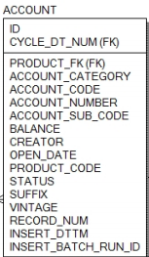

**Key:**

customer.application_id = application.id

1..N

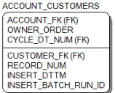

**Key:**

customer.id = account_customers.customer_fk

1..1

**Key:**

account_customers.account_fk = account.id

0..N

**Background:**

* This is an example schema used by banks to track online applications for accounts.
  + The **Customer** table represents all of the customers that have applied for an account through the online application process.
  + The **Application** table represents an actual electronic application submitted by a customer. There may be multiple apps per customer
  + The **Product**represents the product that was selected during the application process. There may be multiple products per application.
  + The **Account**describes the account that was opened during the application process
  + 1..N means a one-to-many relationship, 0..N means zero-to-many, and 1..1 means one-to-one, 0..1 means zero or one row. Arrows denote the join / relationship direction.
  + State any assumptions you’re making about the data as part of the exercise.**It’s OK to make assumptions about field definitions based on the field name**.
  + This exercise tests your ability to deal with **new or uncertain data sets**. There may be multiple correct answers – please select the answer that highlights a succinct, well-thought out approach. Use SQL to express the correct answer when asked – **exact syntax is less important than the thought process behind the SQL**.
  + It’s in your best interest to do your own work and be ready to defend your approach.**Don’t cheat.**

**Consider the following questions:**

* The marketing team is considering new creative materialthat might have broader appeal to customers. They want to know the characteristics of customers whohave already *applied* and *successfully* opened up accounts. At a high-level (without SQL), what table(s) and field(s) would you analyze to provide this information?, Application Table: fields Application_Type, purpose
* , Account table : Balance ,Status
* Product Table : Category
* You have been asked to do a break-down of application statuses (using the *Status* field in the application table) by daytime and evening phone numbers of customers whose application status is ‘pending’. What SQL would you write to answer this question?
* The digital sales team is considering the value of high-balance accounts (any account with an opening balance greater than $2K) and believes there may be a relationship between *opening balance* and*time of day when the application was submitted*.
  + Please note: the Balance field in the Account table contains the opening balance. The submission time in the application table has when the app was submitted.
    - What SQL would you write to show the relationship between opening balance and submission time?
    - What validation tests would you perform to determine if this is a *sound hypothesis*? Please be specific.
    - Assume the hypothesis about opening balance and time-of-submission is proven false. What other fields would you suggest or investigate, if any, which might yield better *causative* relationships for the opening account balance?